**1- Go to the Settings >> Data Objects >> Classes**

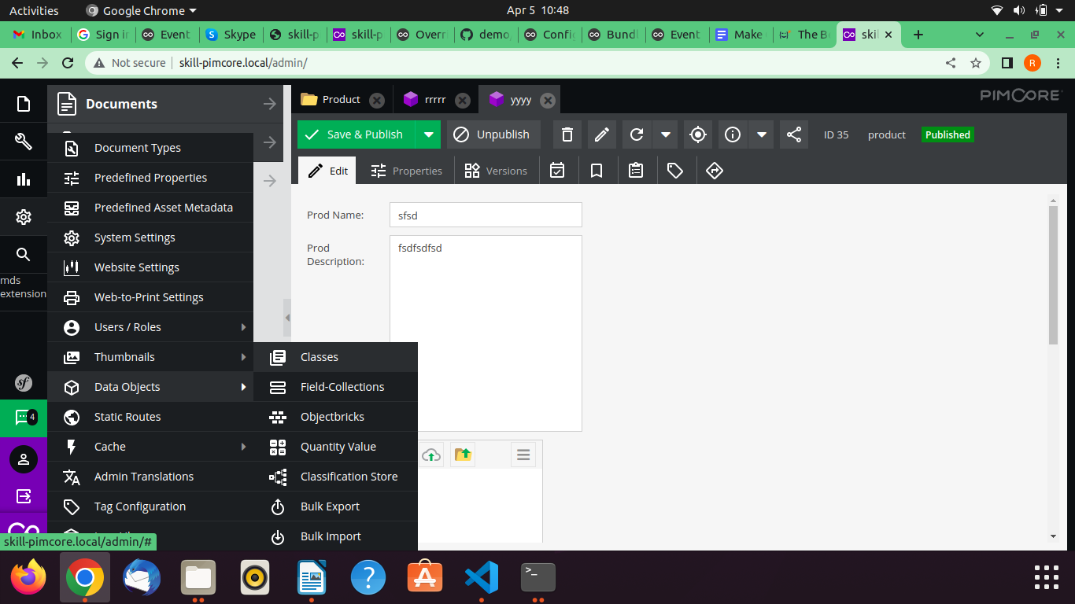

**2- Click on** Add **Button and type the name of the class as and click on**

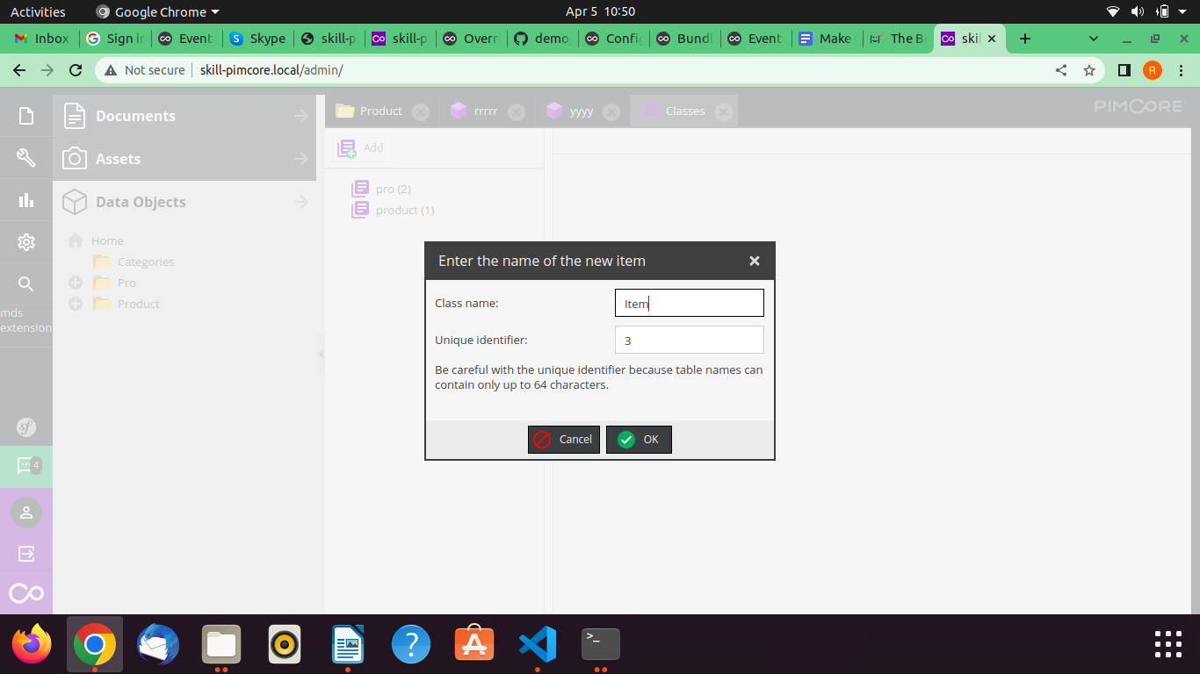

**3- Now go to the general settings and right click on that**

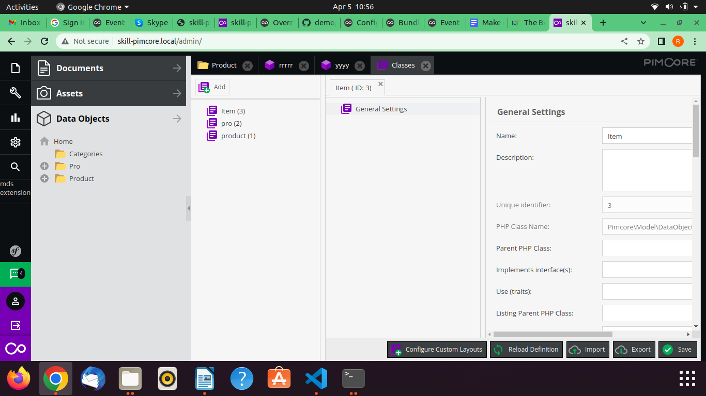

**Add any Layout Component like panel**

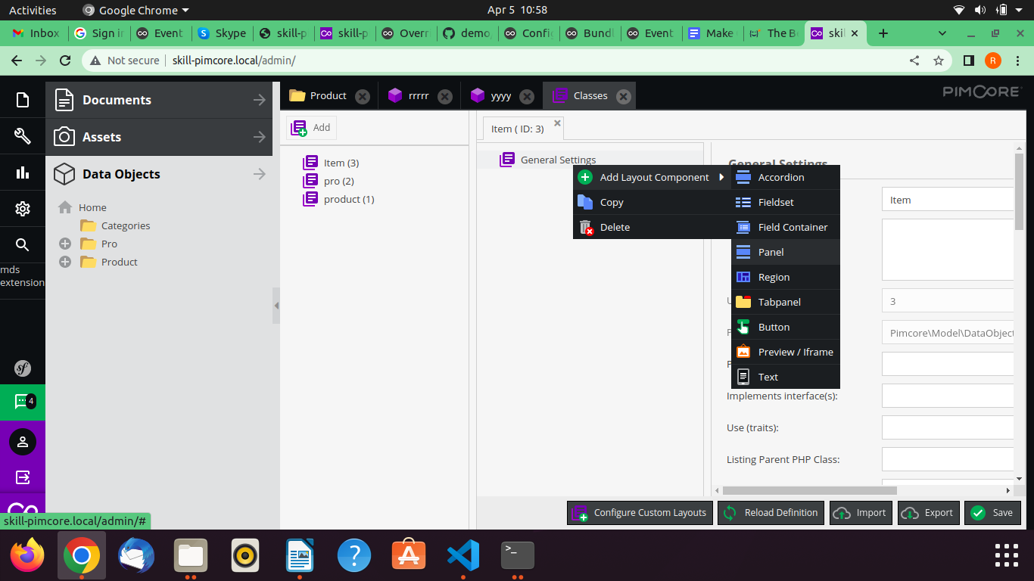

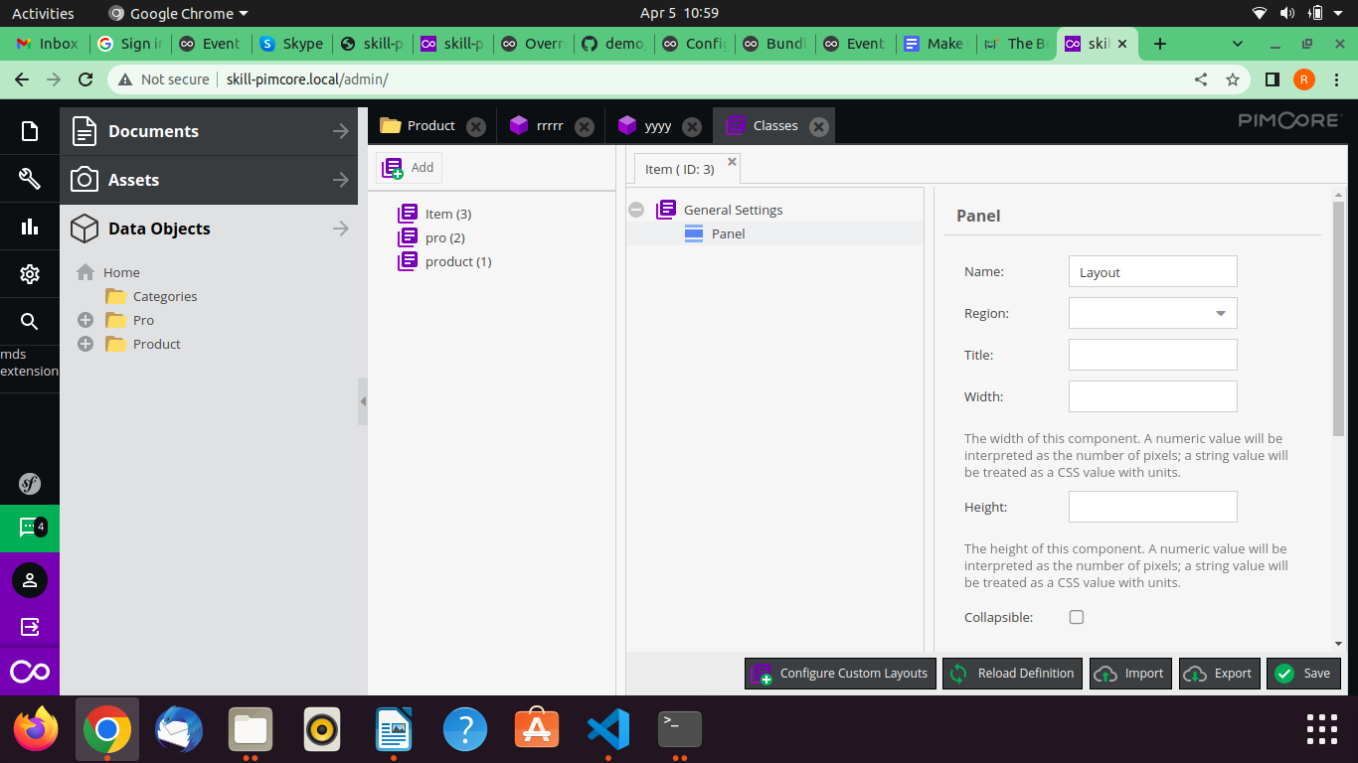

**4- Now right click on Panel and try to add any Data Component like text and the name of textbox and save it.**

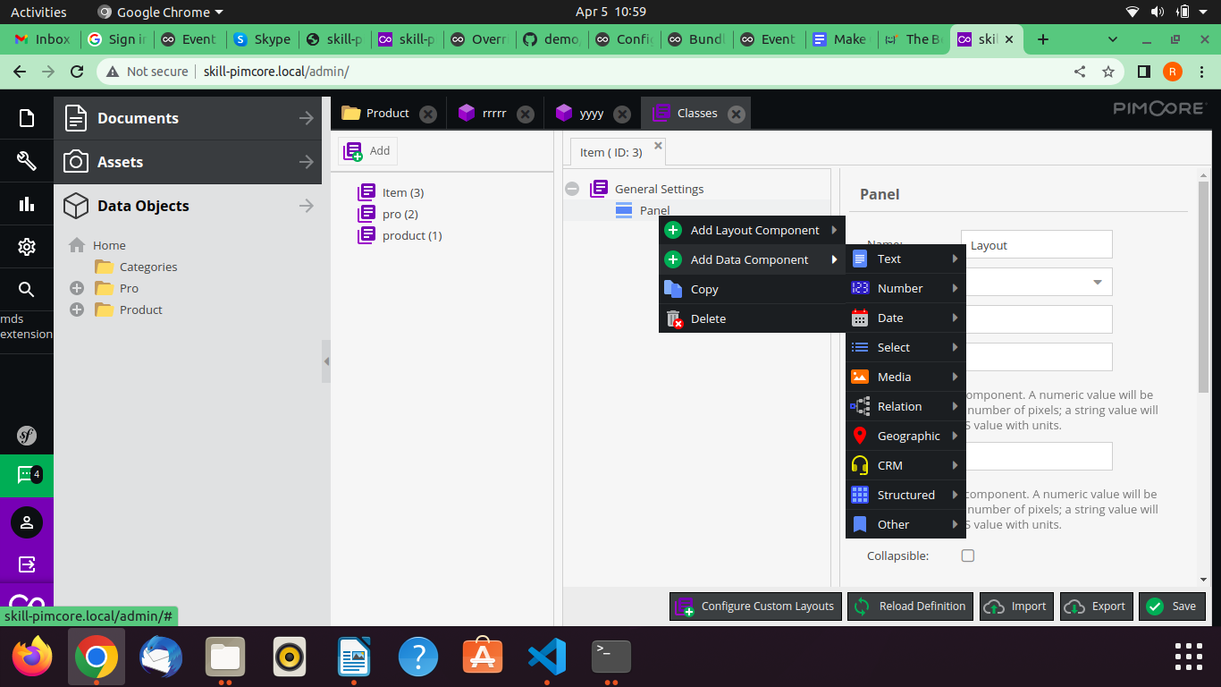

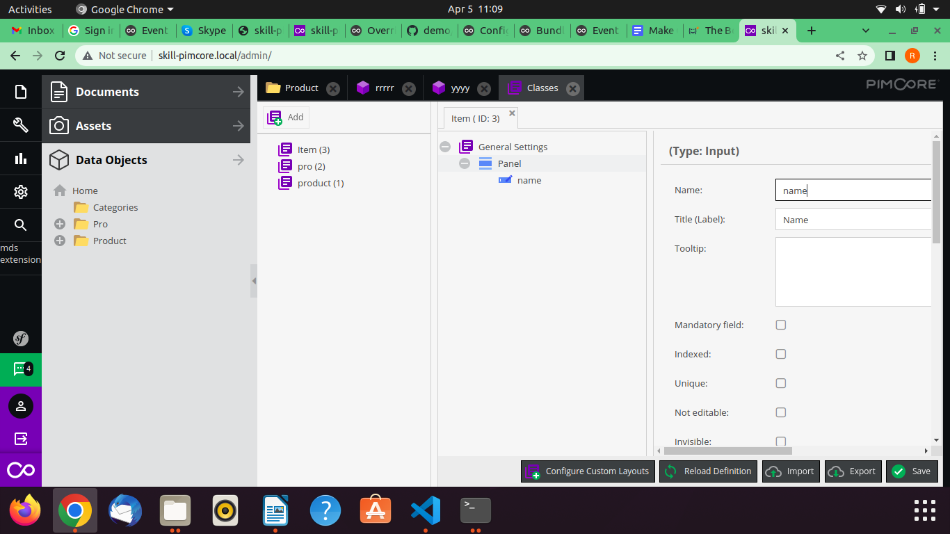

**5- Finally class is created and we can make object of that class**

